ICT942 Cybersecurity Project

Week 01: MCQ and Exploration of Research Databases

Hands-on Activities

Objective
The objective of this lab is to familiarise students with searching for academic papers using Google Scholar and various academic databases such as Elsevier, IEEE, Springer, and Wiley. Students will learn to identify open access and non-open access articles and use advanced search techniques. Students are allowed to use AI tools for searching.

Requirements
- A computer with internet access.
- Access to academic databases (either through the university library or personal access).

Tasks Overview
- Using Google Scholar to find recent papers on specific cybersecurity topics related to your project.
- Exploring academic databases (Elsevier, IEEE, Springer, Wiley).
- Identifying open access vs. non-open access articles.
- Using advanced search techniques.
- Use AI tool of your choice to summarise two papers that are related to your project:
- Abstracts
- Full papers
- Methodology sections
- Findings
- Limitations

Detailed Steps

Task 1: Using Google Scholar
- Access Google Scholar:
  - Open your web browser and go to Google Scholar.

https://scholar.google.com/
- Search for Recent Papers:
  - In the search bar, type "IoT security" and press Enter.
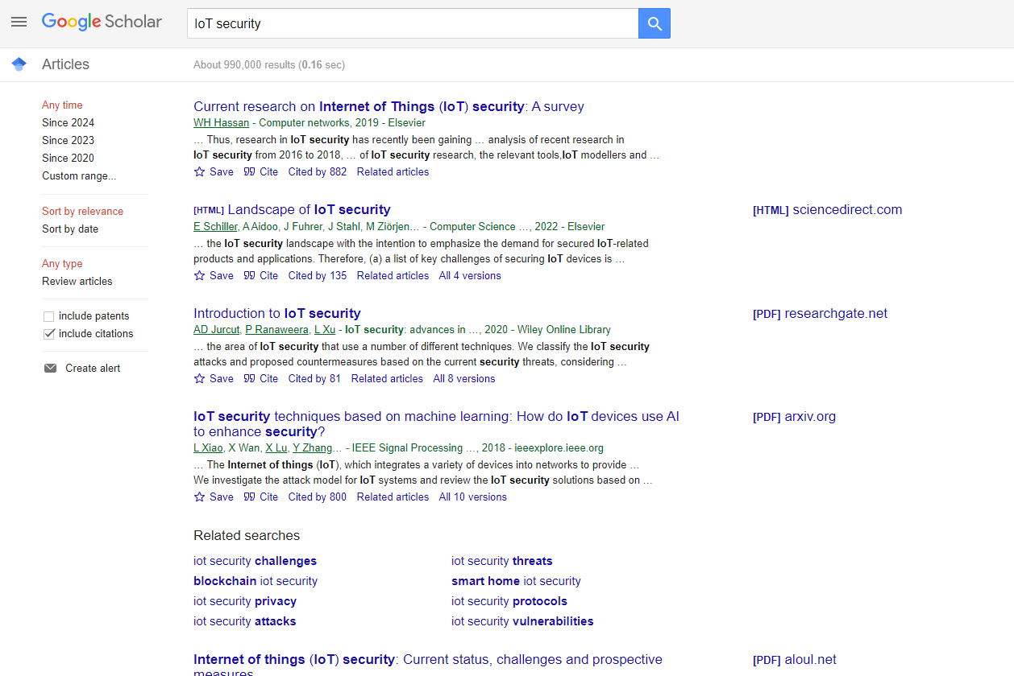
  - On the search results page, click on "Since 2023" on the left sidebar to filter the results to the most recent papers.
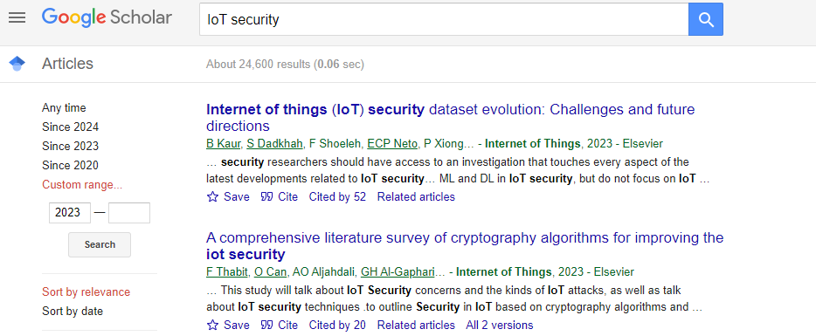
  - Get the APA citation of one of the articles you found
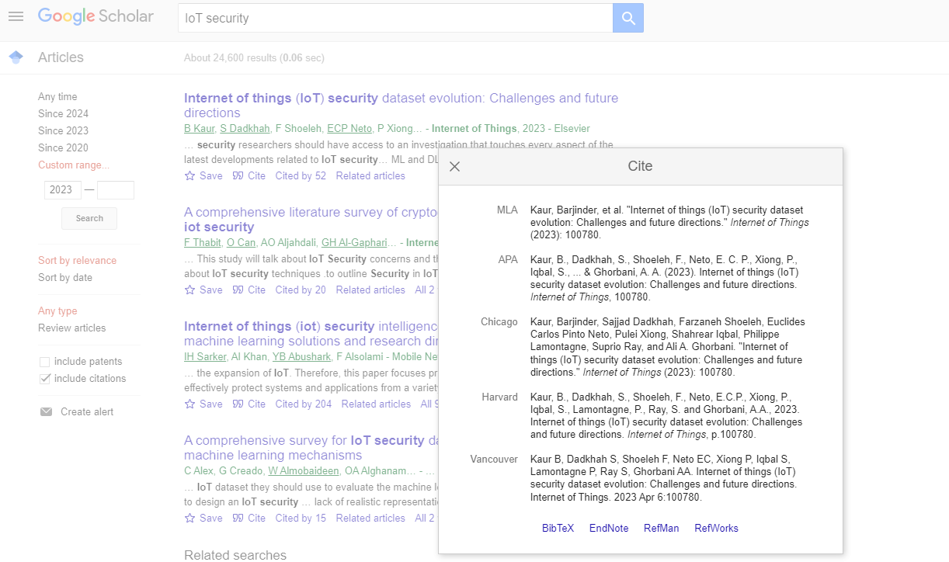
  - Repeat the process with "Cloud security".
- Select a Paper:
  - Browse through the results and select a paper that interests you.
  - Click on the title to access the paper.
- Download the Paper:
  - If the paper is open access, you should be able to download the full PDF directly.
  - If the paper is not open access, take note of the publisher (Elsevier, IEEE, Springer, Wiley, etc.).

Task 2: Exploring Academic Databases
- Accessing Databases:
  - Visit your university library’s website to access academic databases.
  - Alternatively, you can visit the following links:
    - Elsevier
    - IEEE Xplore
    - ScienceDirect
    - SpringerLink
    - Wiley Online Library

- Searching for Papers:
  - Use the search functionality on each database to search for "IoT security" and "Cloud security".
  - Note: You may need to log in with your university/institution credentials to access full articles.
- Downloading Papers:
  - For open access articles, you should see an option to download the full text.
  - For non-open access articles, you may only see an abstract or preview. In such cases, take note of the access status.

Task 3: Identifying Open Access vs. Non-Open Access Articles
- Open Access Identification:
  - Open access articles are usually marked with a label or icon indicating "Open Access".
  - Look for labels like "Open Access", "Free Access", or icons that indicate free availability.
- Non-Open Access Identification:
  - Non-open access articles may have labels like "Subscription Required", "Purchase", or simply no open access indicator.

Task 4: Using Advanced Search Techniques
- Advanced Search on Google Scholar:
  - Click on the menu icon (three horizontal lines) on the top left corner of Google Scholar.
  - Select "Advanced search".
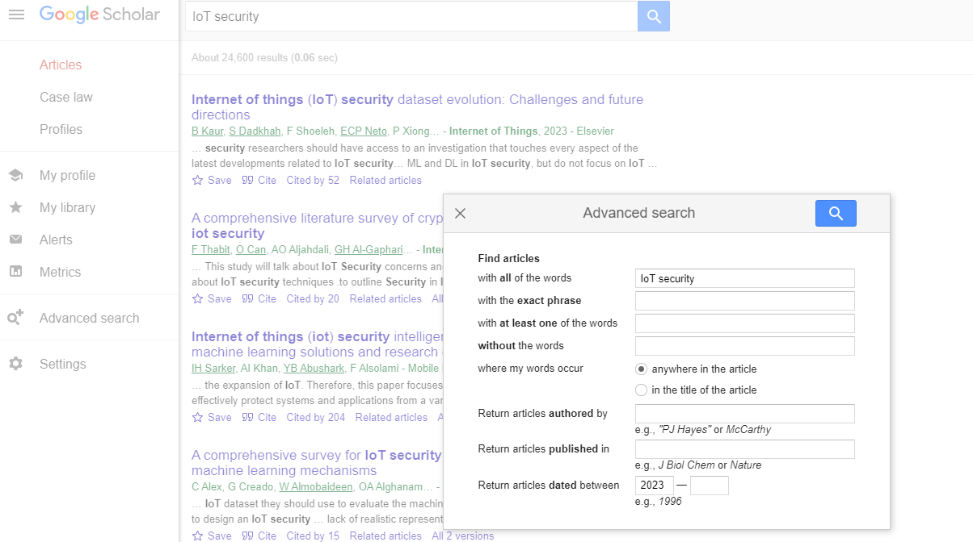
  - Use the various fields to refine your search (e.g., all of the words, exact phrase, at least one of the words, without the words, where my words occur, etc.).
  - Explore the settings on Google Scholar
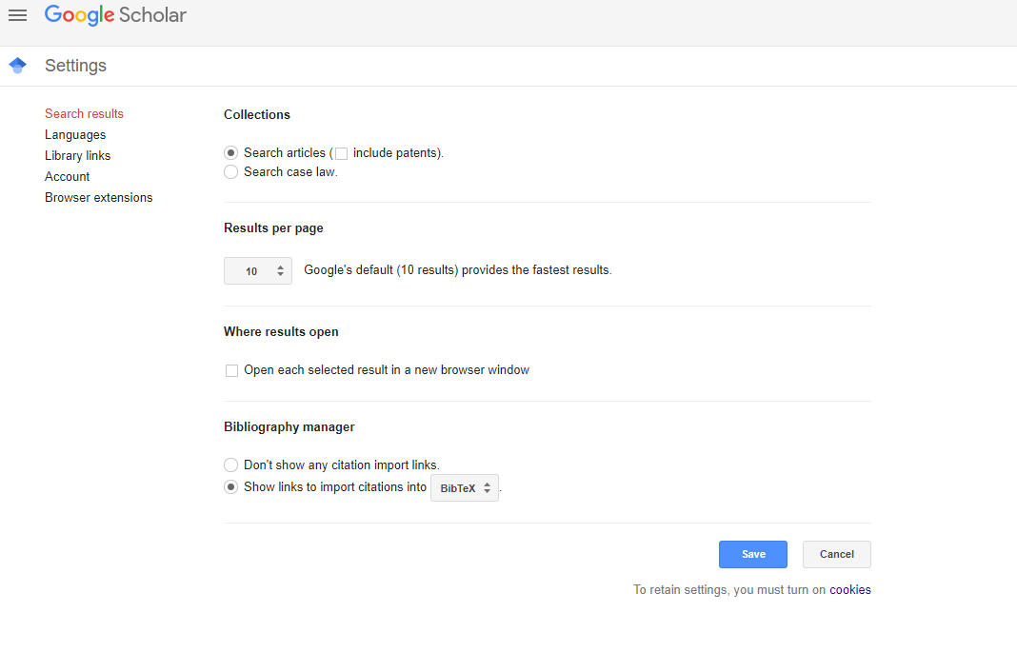
- Advanced Search on Academic Databases:
  - Each database will have its own advanced search functionality. Look for "Advanced Search" options on the search page.
  - Use filters to refine your search results based on publication year, author, journal, keywords, and more.

Task 5: General Search Strategy

Use Boolean Operators:
- AND – all terms must be present
("intrusion detection" AND "machine learning")
- OR – either term may be present
("cyber attack" OR "data breach")
- NOT – exclude a term
("ransomware" NOT "WannaCry")

Use Quotes for Phrases:
- "zero-day attack" finds the exact phrase.

Use Wildcards:
- cybersecur* finds: cybersecurity, cybersecure, cybersecuring.

2. IEEE Xplore Tutorial

Website: https://ieeexplore.ieee.org

Example Queries:
- ("network security" AND "deep learning")
- ("IoT" AND "cybersecurity" AND "anomaly detection")
- "phishing detection" AND transformer

Filters to Apply:
- Publication Years (last 5 years for relevance)
- Content Type: Journals, Conferences
- Author Affiliation (for checking reputable authors)

Tips:
- Use Advanced Search to search within Abstract or Title.
- Use Document Type filter to focus on Journals or Conference Papers.

3. Elsevier ScienceDirect Tutorial

Website: https://www.sciencedirect.com

Example Queries:
- "cyber threat intelligence" AND "machine learning"
- "social engineering" AND "phishing" AND "detection"

Filters to Use:
- Journals & Articles only (not books unless needed)
- Subject Areas: Computer Science, Engineering
- Year Range: 2020–2025

Tips:
- Use the "Advanced Search": You can search in title, abstract, or keywords.
- Prioritize journals like: Computers & Security, Journal of Network and Computer Applications

4. SpringerLink Tutorial

Website: https://link.springer.com

Example Queries:
- "cybersecurity" AND "cloud computing" AND "data leakage prevention"
- "blockchain" AND "IoT security"

Lab Submission Requirements
Submit a report with the following details:
- Google Scholar Search:
  - Title and link of one recent paper on "IoT security" and provide the screenshot of the searching result.

  - Title and link of one recent paper on "Cloud security" and provide the screenshot of the searching result.
  - Copy the APA citation of your chosen papers from Google Scholar and provide the screenshot showing the APA citation
- Database Exploration:
  - Name at least five publishers (Elsevier, IEEE, Springer, Wiley, etc.).
  - Title and link of one paper you found on each database.
  - Copy the APA citation of one paper from the journal page and provide the screenshots showing APA citation.
- Open Access vs. Non-Open Access:
  - Identify and list one open access paper and one non-open access paper from your search and provide the screenshots showing the articles.
  - Describe how you identified their access status.
- Advanced Search:
  - Describe your experience using the advanced search on Google Scholar and one academic database.
  - Provide screenshots showing your advanced search criteria and results.
- Structured Query
  - Write at least one structured search query for IEEE Xplore and Elsevier (ScienceDirect) and provide screenshots of the results. The query must include Boolean operators (AND, OR, NOT), phrase matching using quotes, keywords relevant to your topic such as IoT security, Cloud security.
  - Provide screenshots of filtering the results based on year, document type (journals, conferences), subject area or disciplines filters.

Submission:
Please submit a summary of the two papers relevant to your project. Each paper’s summary should include the following sections:
a. Abstract
b. Full paper overview
c. Methodology
d. Key findings
e. Limitations

